Anagha E S

VLOOKUP AND HLOOKUP

* **VLOOKUP and HLOOKUP are Excel functions that allow users to extract data from a table by referencing a key value**
* **VLOOKUP and HLOOKUP are two of the most frequently used functions in Excel.**

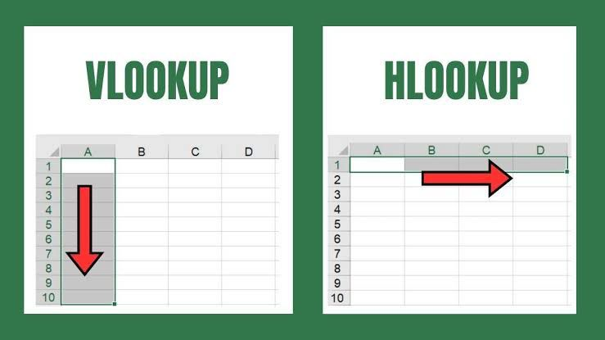**VLOOKUP**

**Stands for Vertical Lookup, and is used to find a value in a table's first column and retrieve a corresponding value from the same row in a specified column. VLOOKUP is used when comparison values are located in a column to the left of the data being found**

**HLOOKUP**

**Stands for Horizontal Lookup, and is used to find a value in the first row of a table and return a matching value from the same column in a designated row. HLOOKUP is used when comparison values are located in a row across the top of a table of data**